CAUSE ONE EXAMPLE :

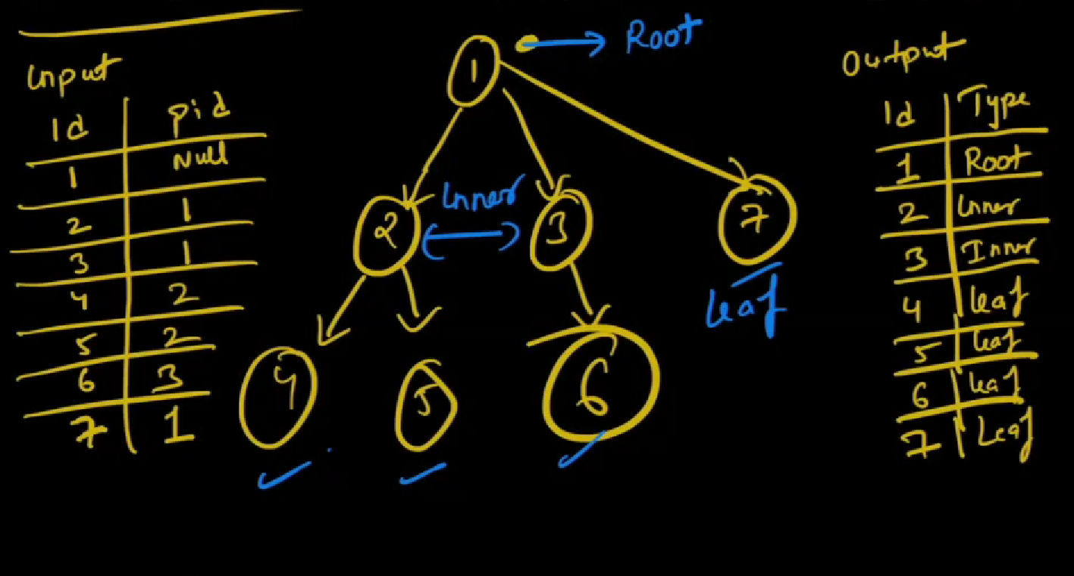

Basically we should put output has

1. ROOT – 1 which has null value
2. 2 ,3 - INNER
3. 4,5,6 – LEAF
4. Query :

Select

Id,

Case

When id IN (select id from tree where p_id is NULL) THEN ‘ROOT’

1. INNER query :

We can check like if p_id is in id column then then its inner

=🡺 When id IN (select p_id from tree) THEN ‘INNER’

WHOLE QUERY :

Select

ID

Case

When id IN (select id from tree where p_id is NULL) THEN ‘ROOT’

When id IN (select p_id from tree) THEN ‘INNER’

ELSE “LEAF”

END AS “Classification”

JOINS

LEFT JOIN

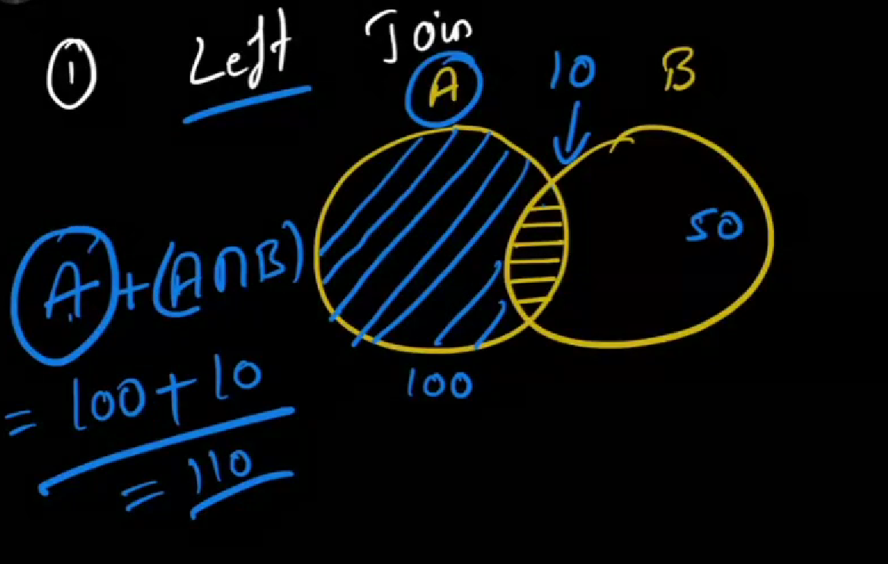

JOINS EXAMPLE :

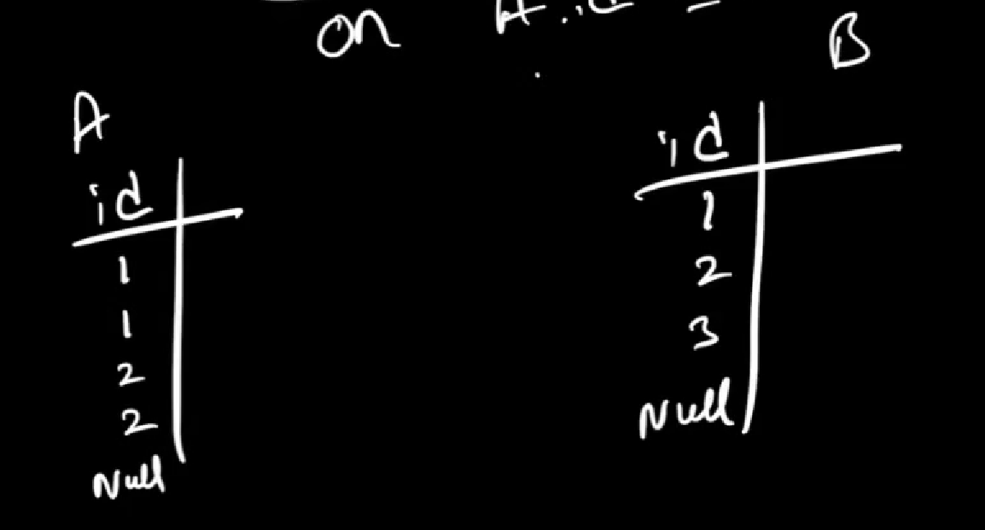

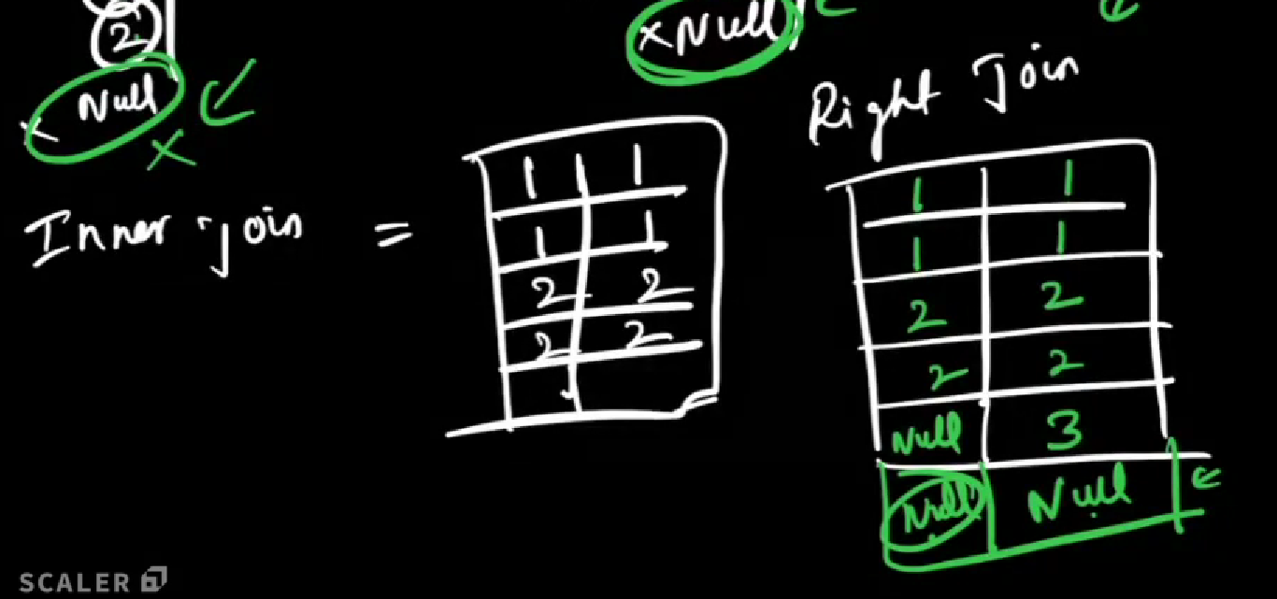

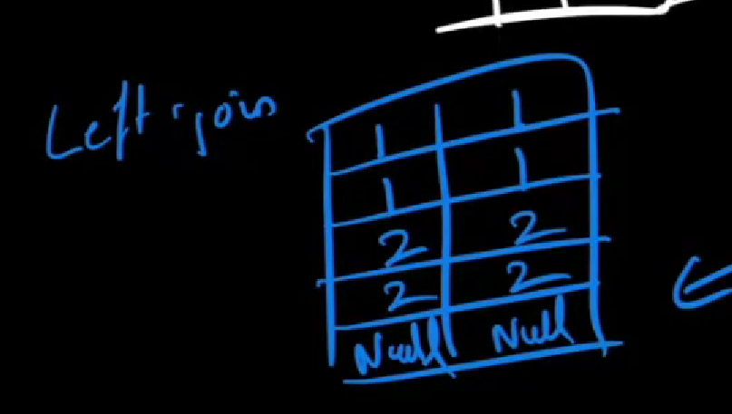

INNER JOIN

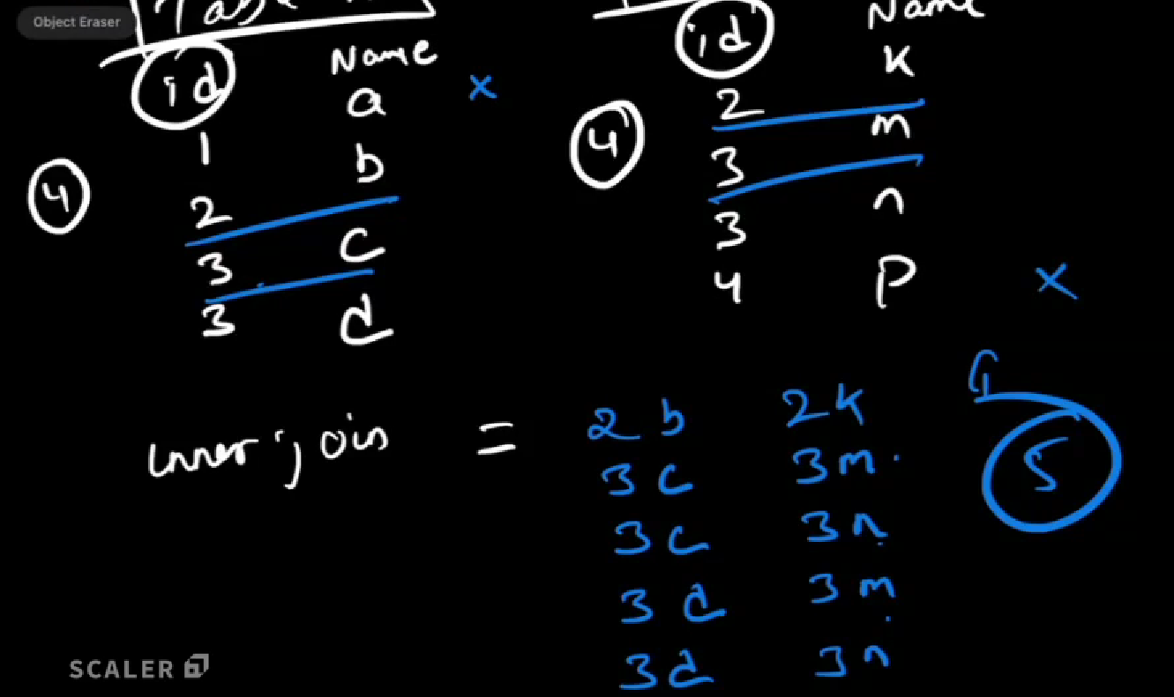

**FULL OUTER JOIN** FOR ABOVE EXAMPLE

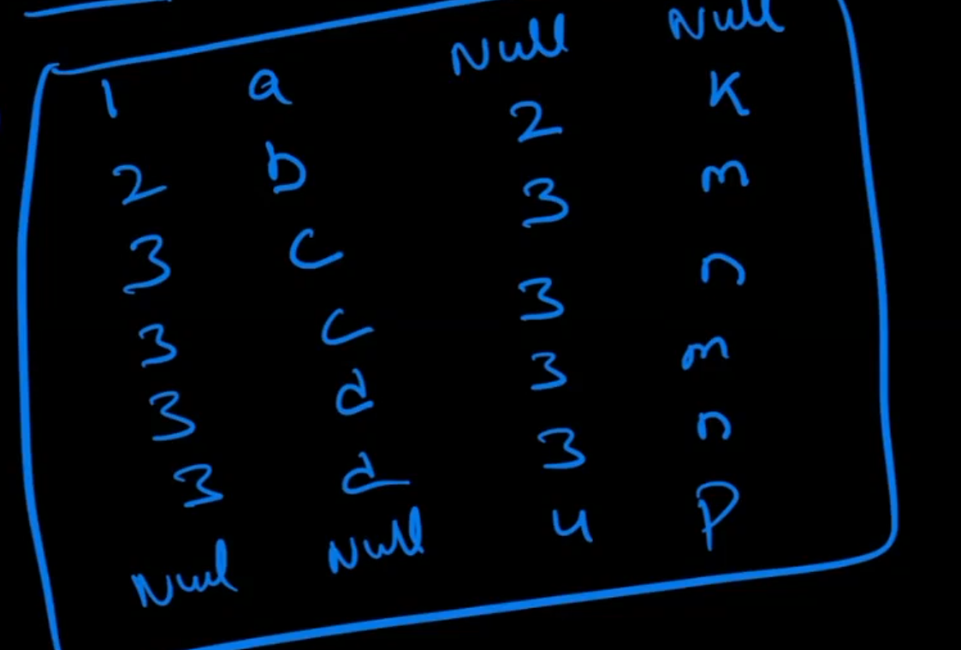

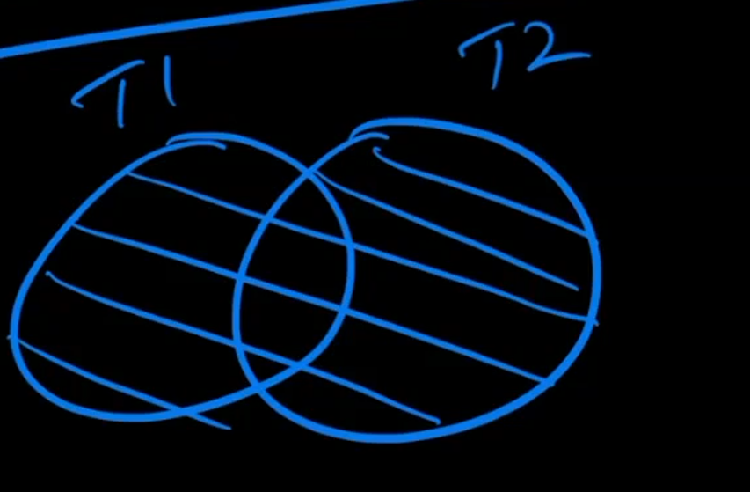

CROSS JOIN

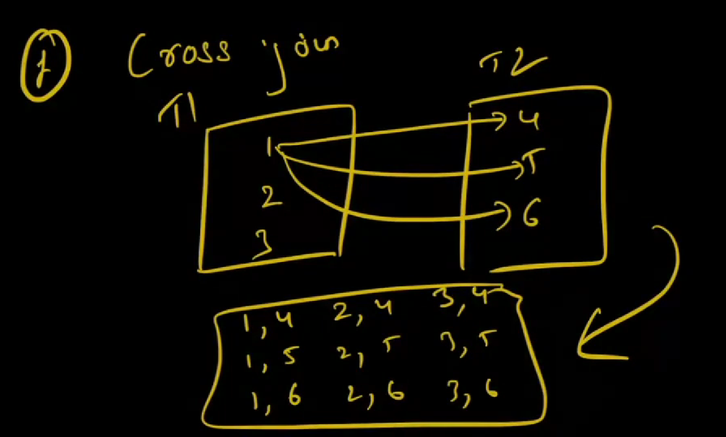

SELF JOIN

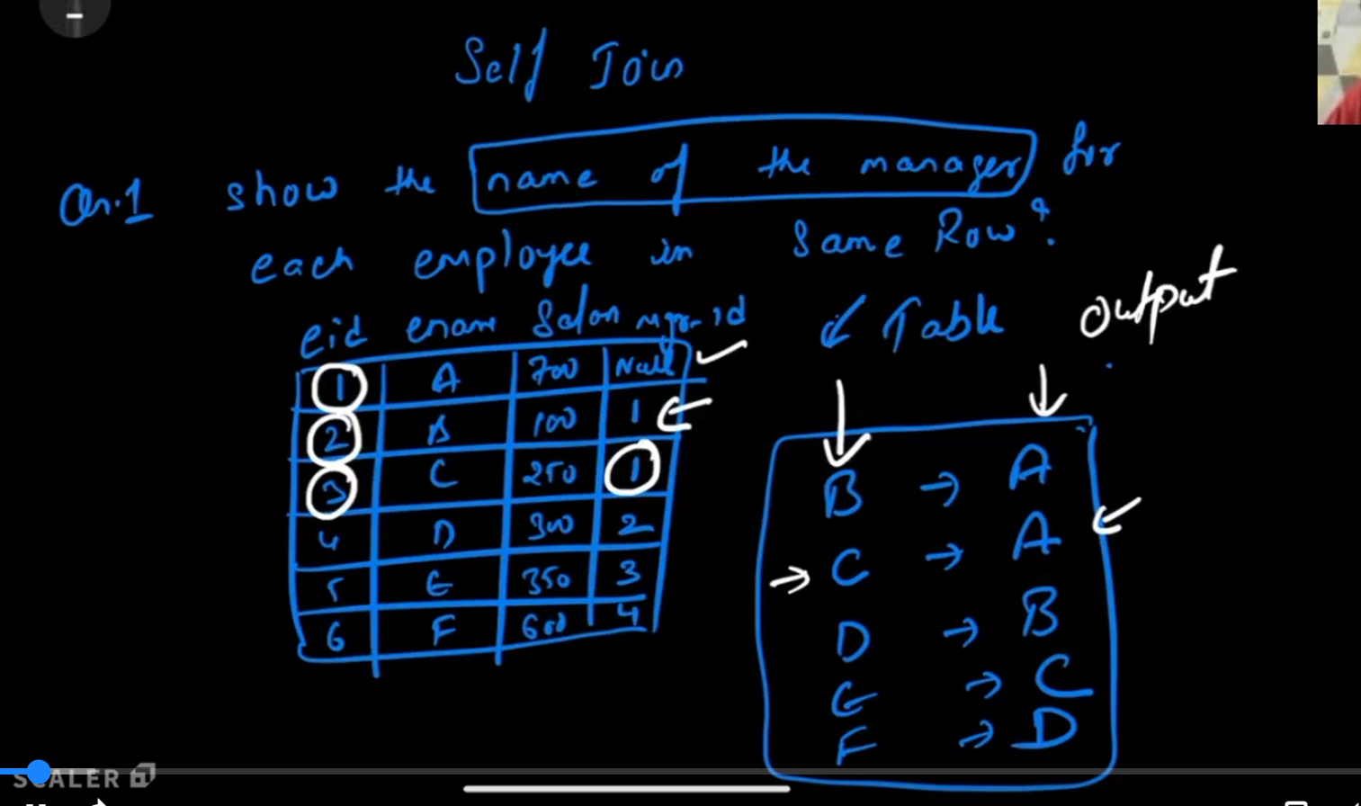

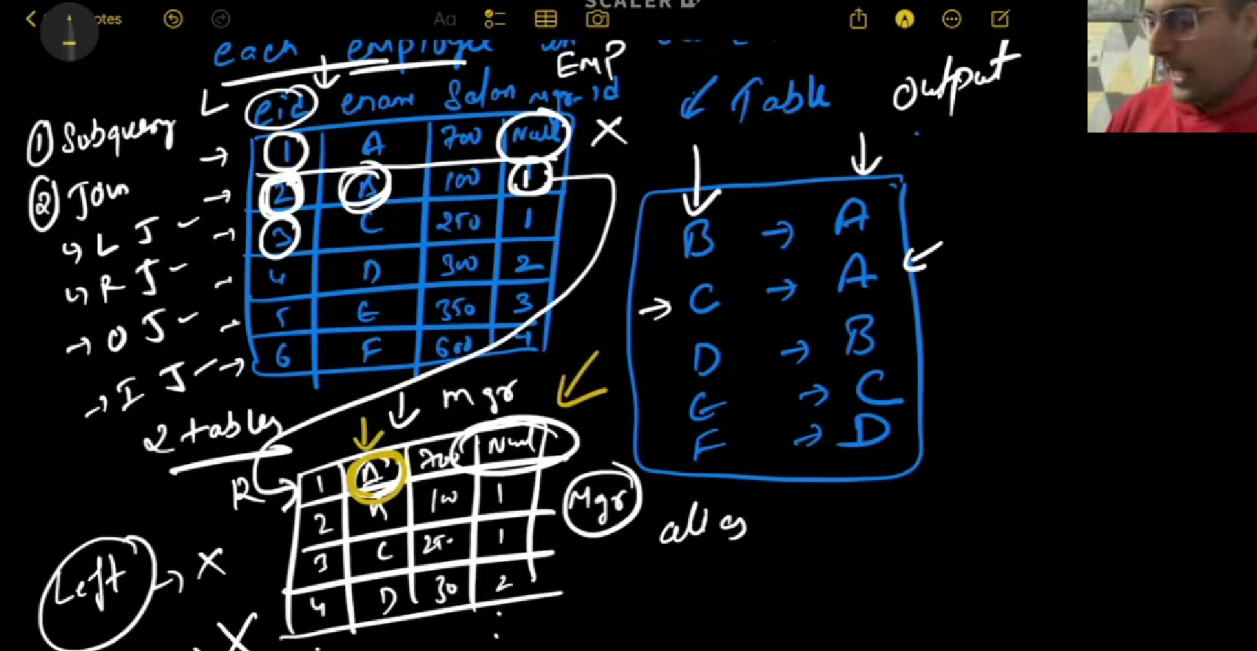

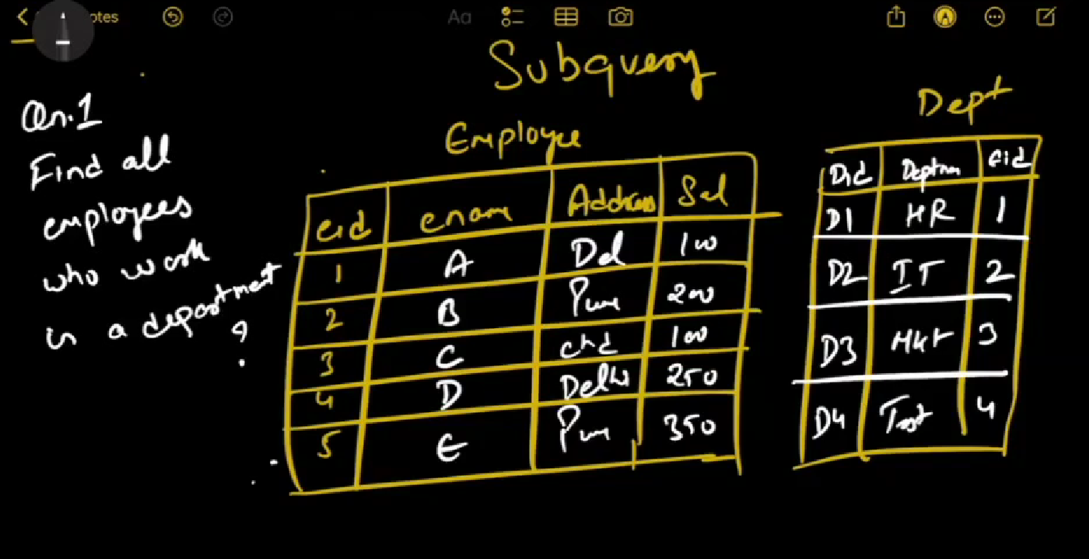

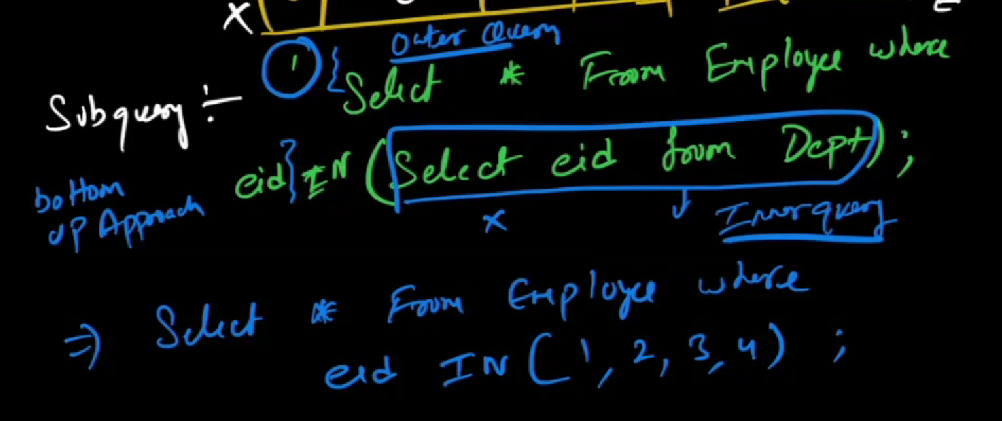

In above subquery Inner query is not dependent on the outer query they are independent.

It is bottom up approach

What if the inner query is dependent on outer query -- correlated query

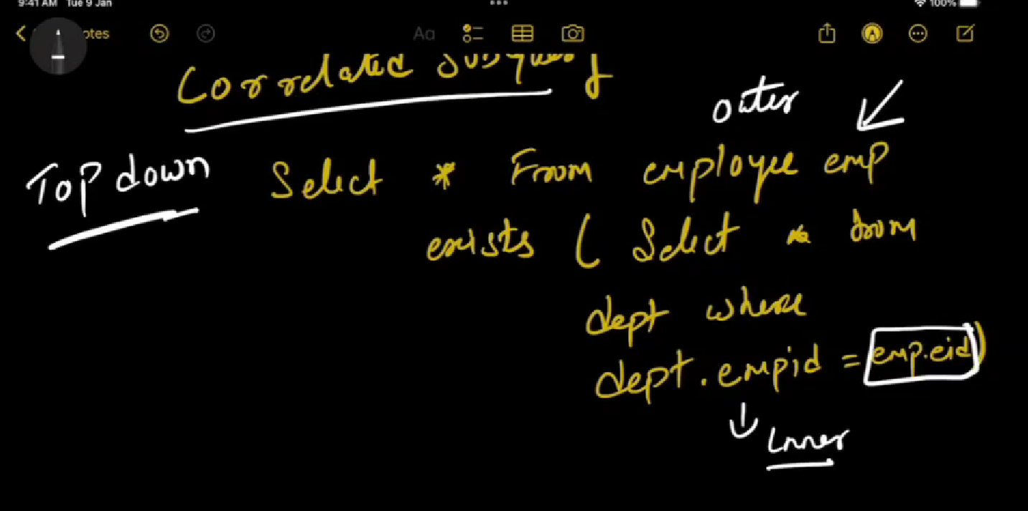

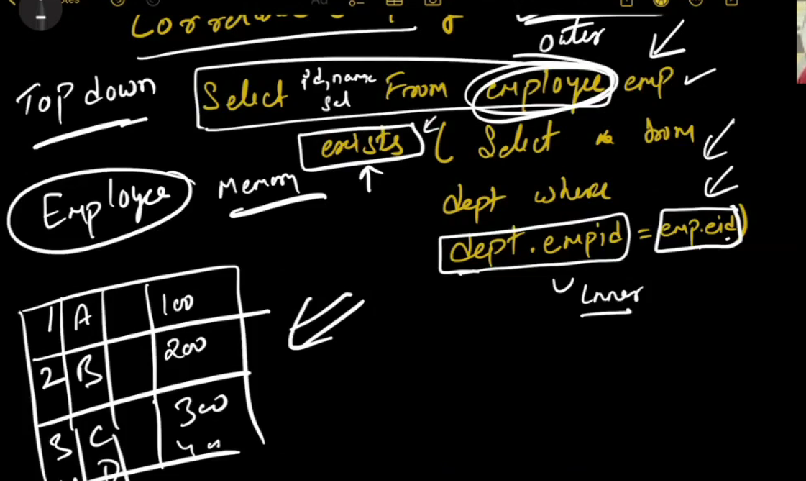

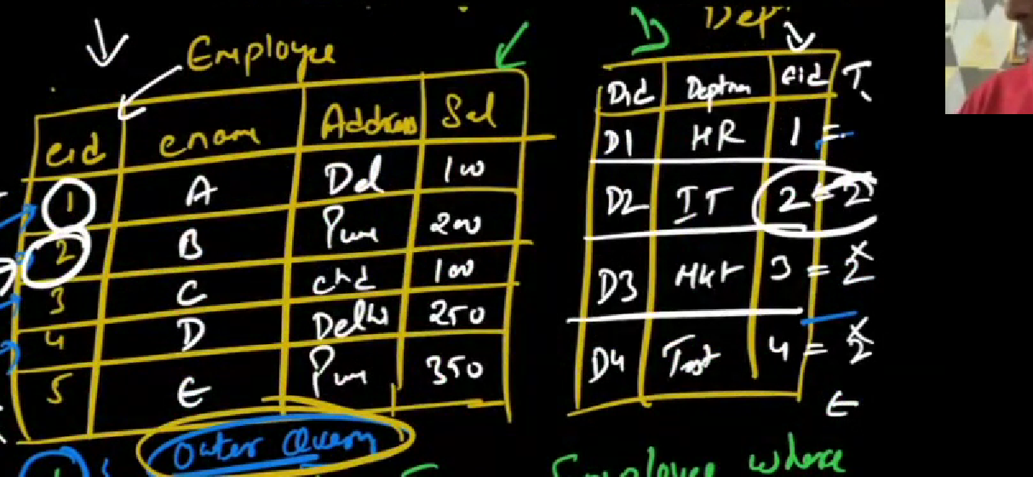

Example : for emp 2. Here it will check with each row in dept table. This happens for all records in employee id

Its kind of recursion.

Subquery – Time complexity => 2n

Correlated subquery – n square

----------------- AGGREGATE FUNCTIONS ------------------------------------------

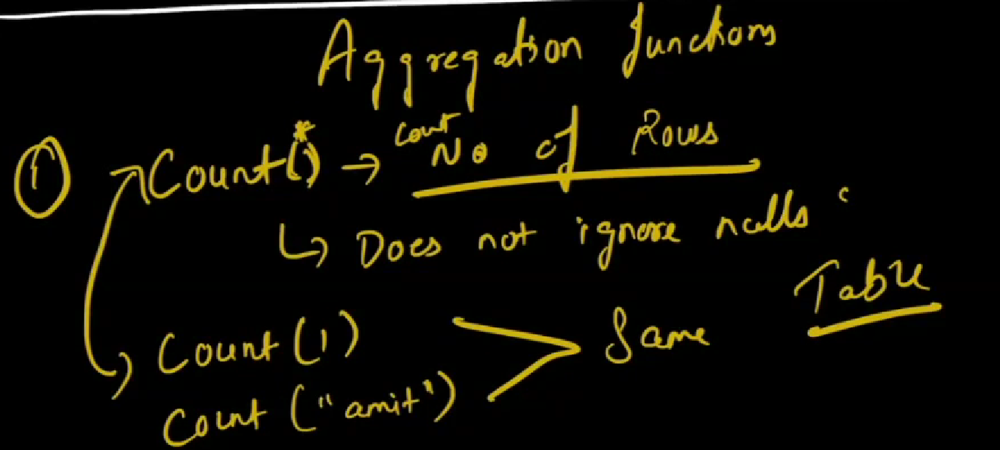

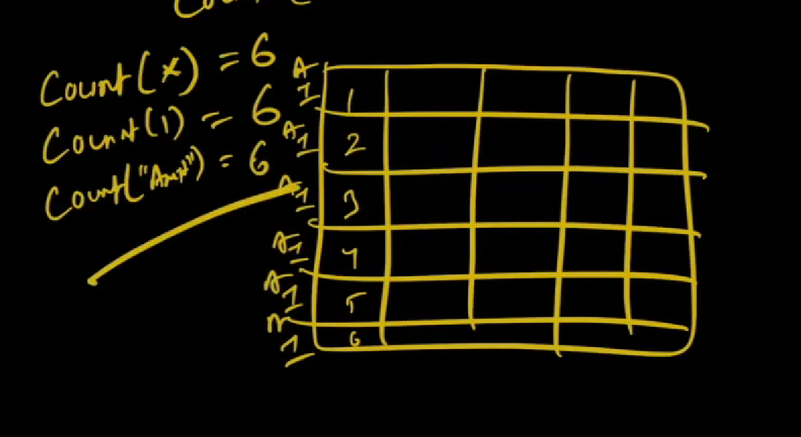

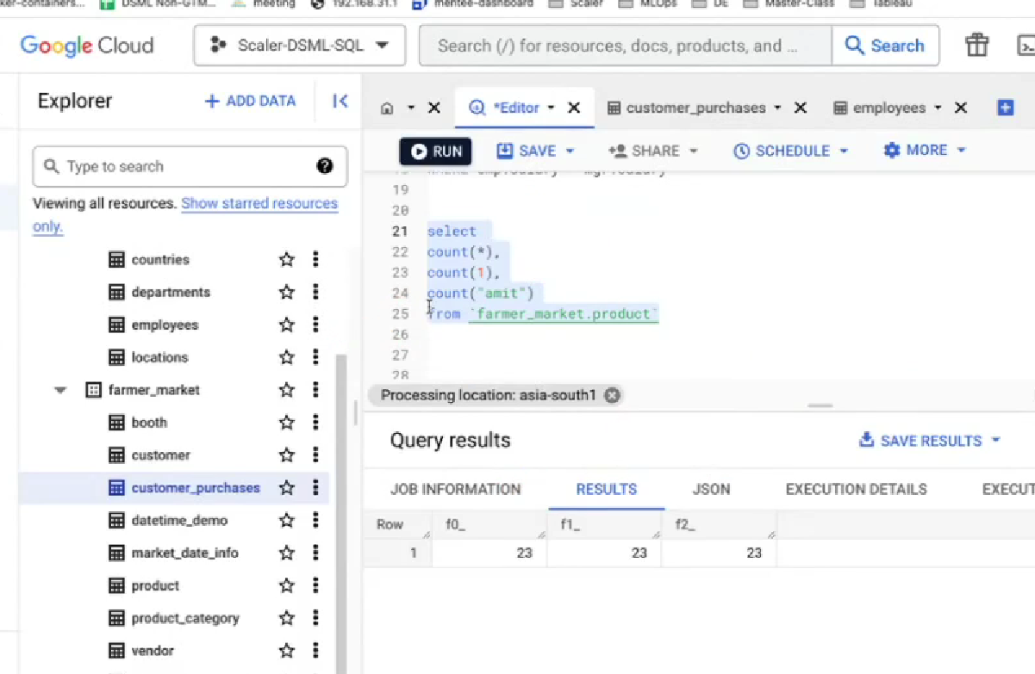

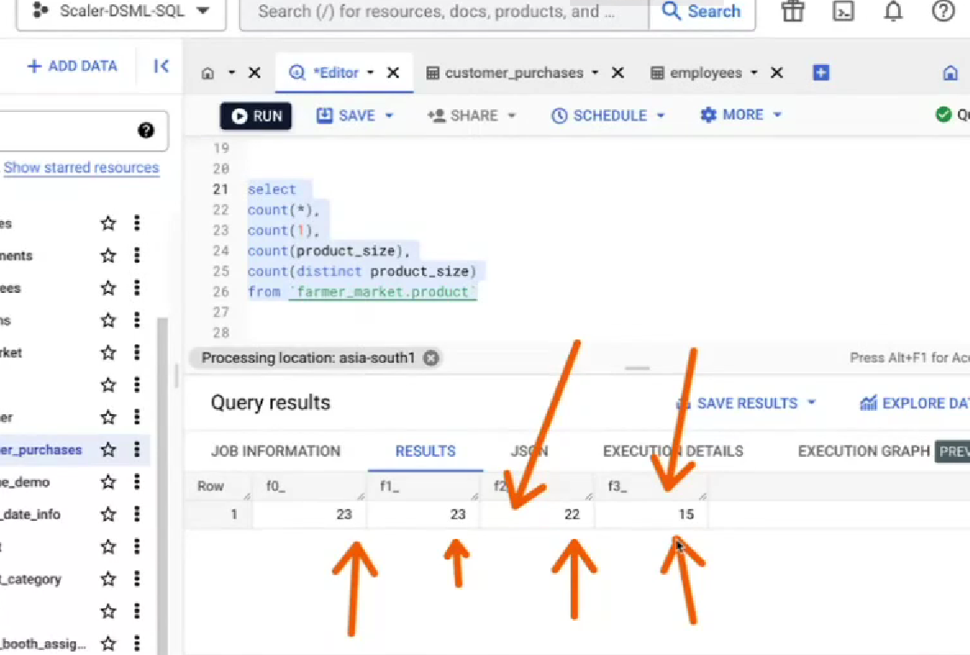

Count(col_name) – ignore null value

Count(distinct col_name) – it will remove duplicats and give

1. SUM - addition
2. AVG ()
3. Min()
4. Max()

----------------------------------------- GROUP BY ------------------------------------------------

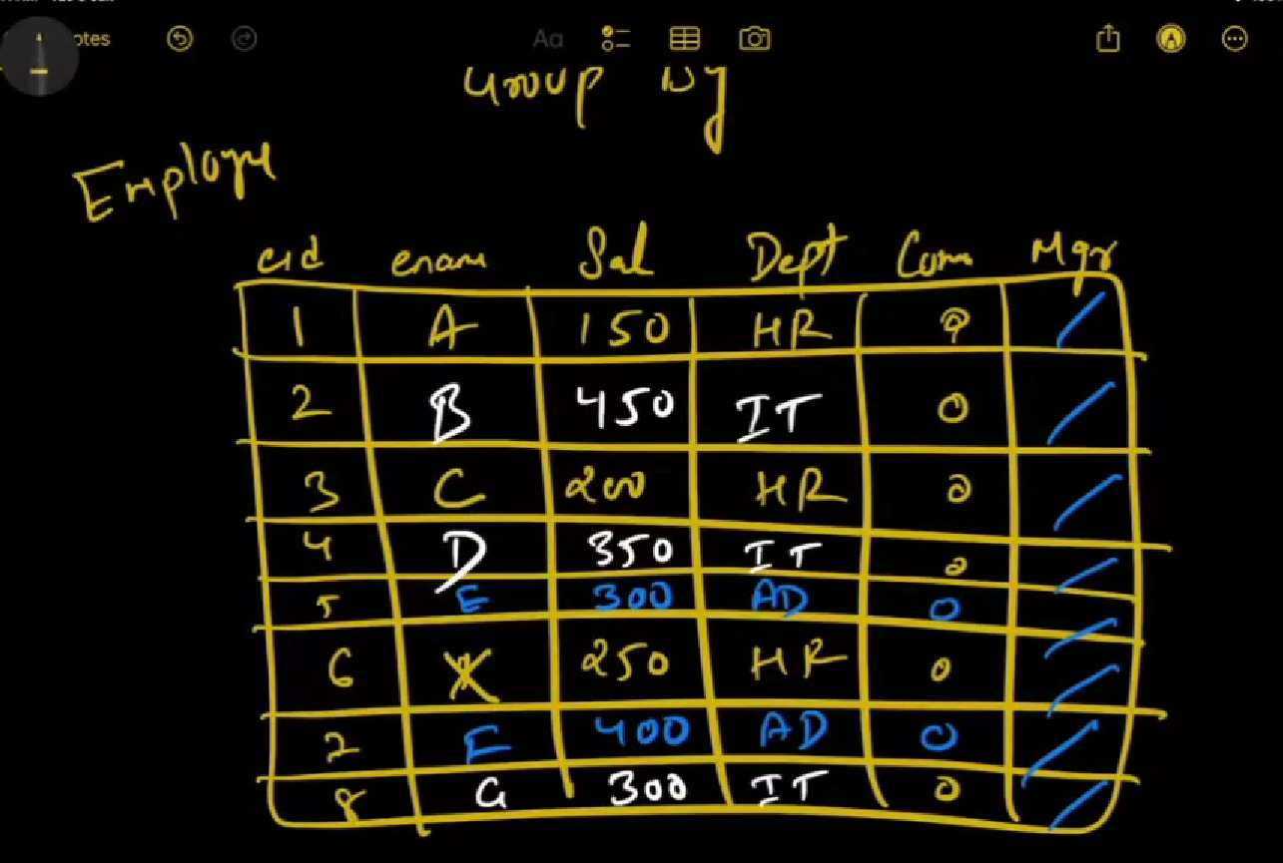

Based on dept we can grp

1. HR
2. IT
3. Admin

QUERY

Select * from employee Group by dept

Group 1

A HR

C HR

X HR

Group 2

B IT

D IT

G IT

Group 3

E admin

F admin

Note : In group by we can add more than one columns

If we give more than one columns the condition is col_name1 <AND logical operator> col_name2

TABLE :

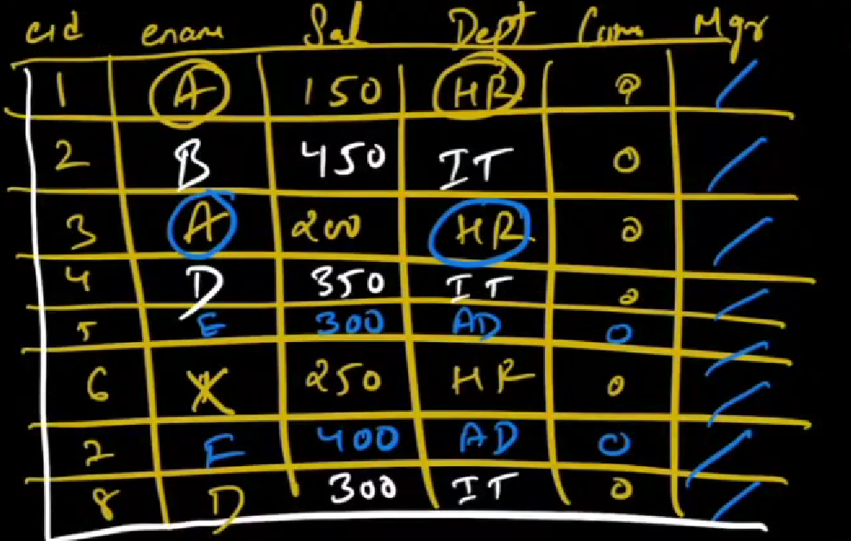

Select * from employee group by dept_id , enmname;

Group 1

A HR

A HR

Group 2

B IT

Group 3

D IT

D IT

Group 4

E AD

E AD

Group 5

X HR

JOINS ASSIGHNEMNT

1. Shortest distance

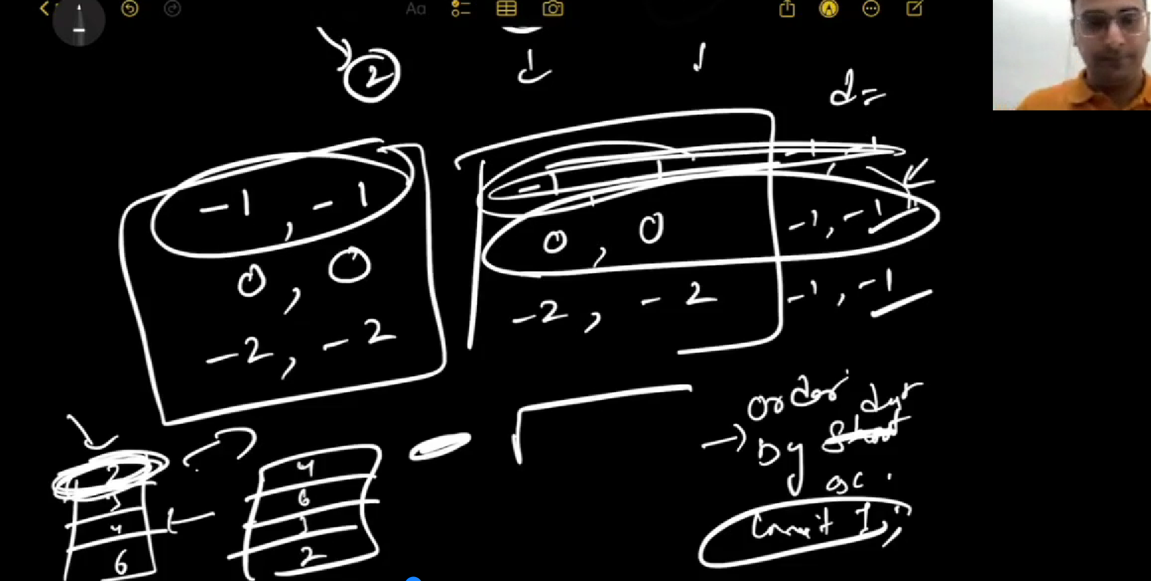

WINDOW FUNCTION ASSIGHMNENT

RECOMMENDATION

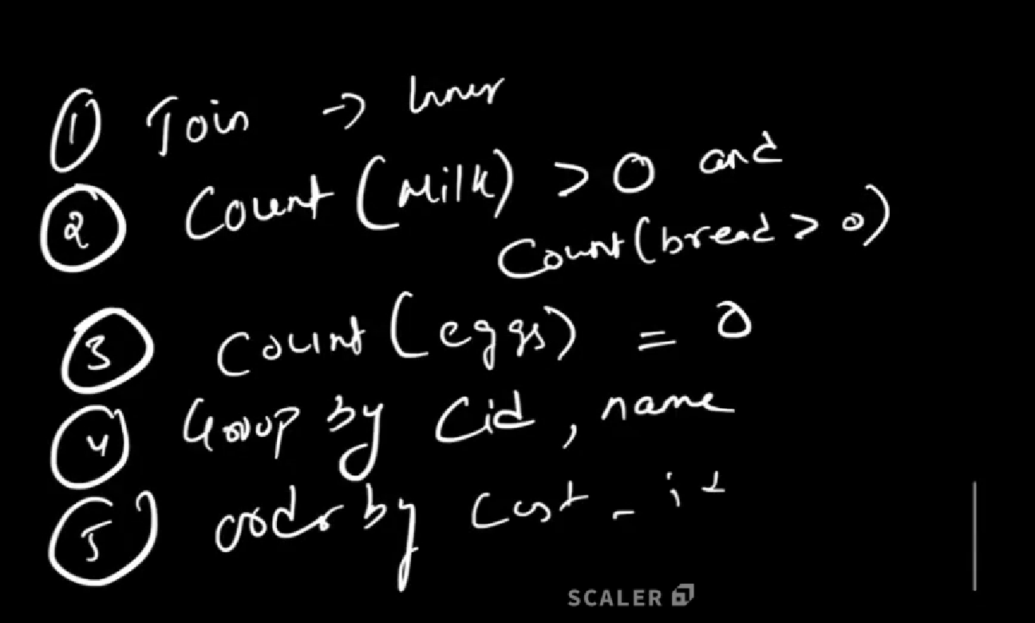

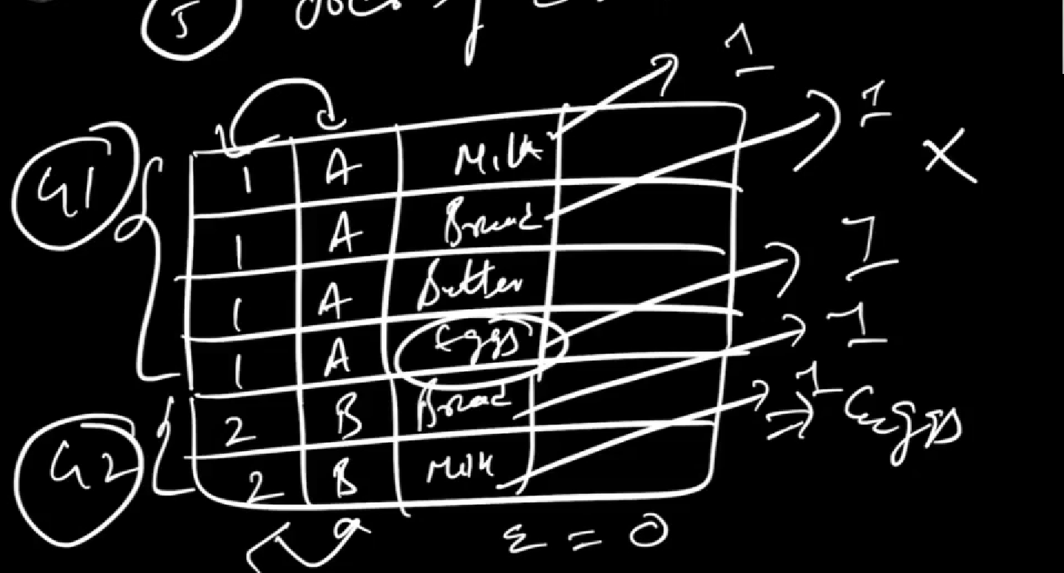

NEW QUESTION

